FINEX // BLOCKCHAIN INTELLIGENCE
Evidence sheet
What this tool claims, and how to check every word of it · SIH 2026 · PS 26183 · Ministry of Home Affairs / I4C
THE CLAIM  From one victim-reported wallet, FineX names the customer deposit address at the exchange that received the money — the account that can be restrained — and states whether the money is still reachable.  WHAT ONE CASE PRODUCES  — A disposition. CRITICAL (funds still at rest), SUSPICIOUS (a freezable exit named), or CLOSED (mixer or sanctioned — nothing follows).  — The exit. The deposit address, with its confidence and the tier of evidence behind it.  — The reasons. Six behavioural rules, each stating in plain words why it fired.  — The file. An evidence packet carrying the SHA-256 of every chain response, and a draft restraint request.  THE DATASET — DERIVED, NOT LICENSED  — The rule. An address that sweeps into one tagged exchange wallet at least twice, forwarding 90% or more of everything it receives, is a customer deposit address at that exchange.  — The result. 241 deposit addresses across 10 exchanges, from 15 explorer-tagged seed wallets, plus 334 OFAC-sanctioned TRON addresses — 590 labels in all.  — The cost. ₹0 in commercial data licences. Public endpoints and the published sanctions list only.  HOW TO CHECK US  — Re-read from the chain. An independent verifier re-reads every transaction a case rests on, importing nothing from the tracer: 33 confirmed, 0 mismatched, 0 missing.  — Re-test the clustering. 40 derived addresses sampled and re-read; all 31 that could be read still meet the rule.  — Read confidence correctly. It measures how much sweep evidence was seen — not the probability the attribution is right.  — Ownership. Only the exchange can confirm who holds an account. The packet says so in writing.  SCOPE, STATED PLAINLY  — TRON and USDT only. Cross-chain tracing, NCRP/SAHYOG intake and departmental indexing are designed and next — not claimed as built.  — No model decides anything. No machine-learning model and no language model runs in this system at all. | OPEN IT  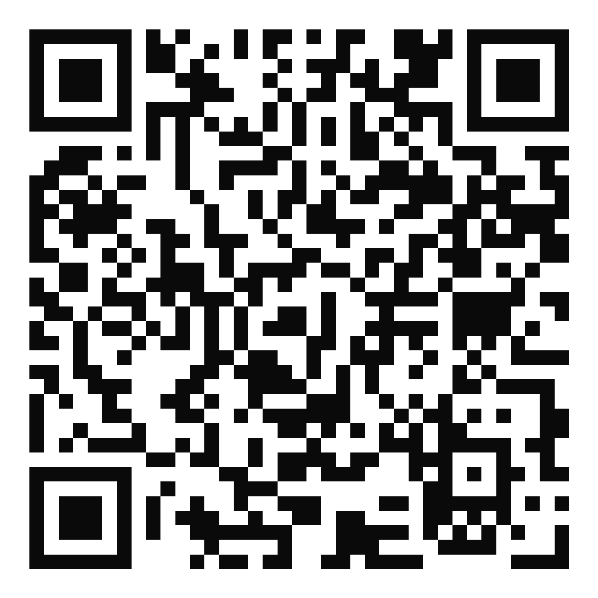  crypto-fraud-tracer.onrender.com  A working deployment, not a mock-up. Three recorded cases open straight from the front page.  THE NUMBERS  241 deposit addresses  10 exchanges covered  15 public seed wallets  334 sanctioned addresses  6 behavioural rules  10 cases frozen with hashes  1 added dependency  ₹0 licence cost  Every figure is counted from the committed repository.
Standing limitation. Attribution produced here is an investigative lead carrying a stated confidence and a stated evidence tier. It is not, on its own, grounds for freezing an account — every evidence packet says so on the page an officer would file.

